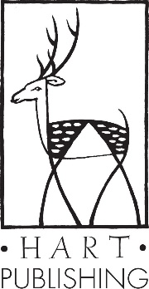
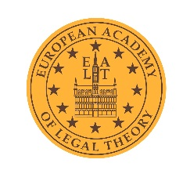

The European Award for Legal Theory

The European Award for Legal Theory is presented to the author of the best doctoral thesis in the area of legal theory and philosophy of law, successfully defended at a university in Europe.
The award entails publication of the thesis by Hart Publishing Ltd. (Oxford), and offers the opportunity to deliver a seminar on the LL.M. in Legal Theory at Frankfurt.

The award will be granted once every two years, the next to be in 2020.
Authors should submit their thesis before April 1, 2020.

Doctoral theses submitted for this award should meet the following conditions:
- The thesis should have been examined after 1 January 2018
- The version submitted should be written in, or translated into, English
- Two hard copies should be submitted by post to:
European Award for Legal Theory
c/o Professor Mark Van Hoecke
Department of Legal History and Legal Theory
Ghent University
Universiteitsstraat 4
B-9000 Ghent
Belgium
- An electronic version of the thesis (Word, PDF, or scan) AND a summary (in English) of between 20 and 50 pages (font 11 or 12, 1.5 spacing) should be submitted by e-mail to both the following addresses:
Mark.VanHoecke@UGent.be & m.vanhoecke@qmul.ac.uk
- The thesis must not be contracted by an operating commercial publishing house before the Award is assigned.

The award is, as a rule, assigned by a jury of seven members from different regions in Europe, with members fairly representing various sub-disciplines within legal theory and philosophy of law.
If the thesis is written in publishable English, the publisher will pay royalties on the net sales receipt to the author. If language correction is necessary, the publisher will pay for this up to a maximum of £500 and no royalties will be paid.

